Quizlet instructions - Setting up

The pictures show an example for year 3 – Select appropriate year group

Every year group has been sent a different invitation.

1. click on the link below inviting you to join the Quizlet class and paste it in the browser. You can also type it in.

<https://quizlet.com/join/zmrpDURDr>

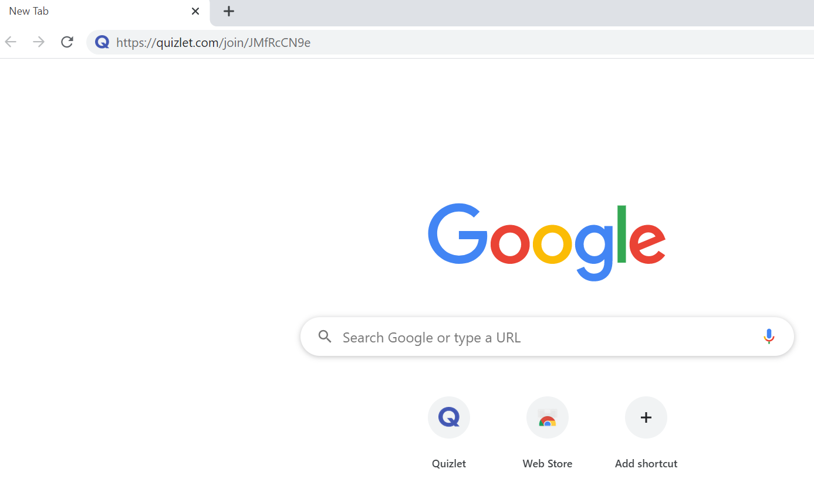

1. It will open this window in [www.quizlet.com](http://www.quizlet.com) . Click here

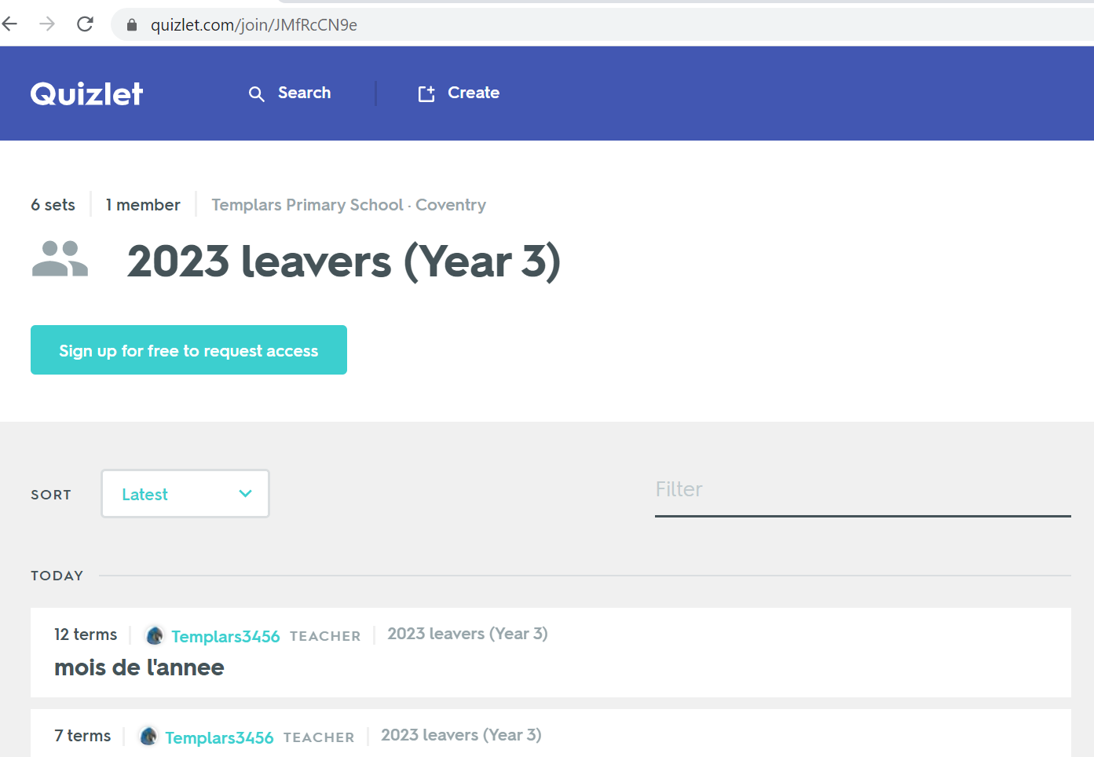

1. To create an account, enter your username and password into the correct fields.

**Date of birth:** you can enter your real date of birth

**Username**: the first 3 letters of your child’s first name, followed by first three letters of your child’s surname, followed by tps followed by the year leaving year 6. (example John Smith, end of year 6 in 2023: johsmitps2023)

**Parents email**: please enter an email address.

**Password**: **templars**. **Please do not change your password as they cannot be reset.**

Accept terms and conditions.

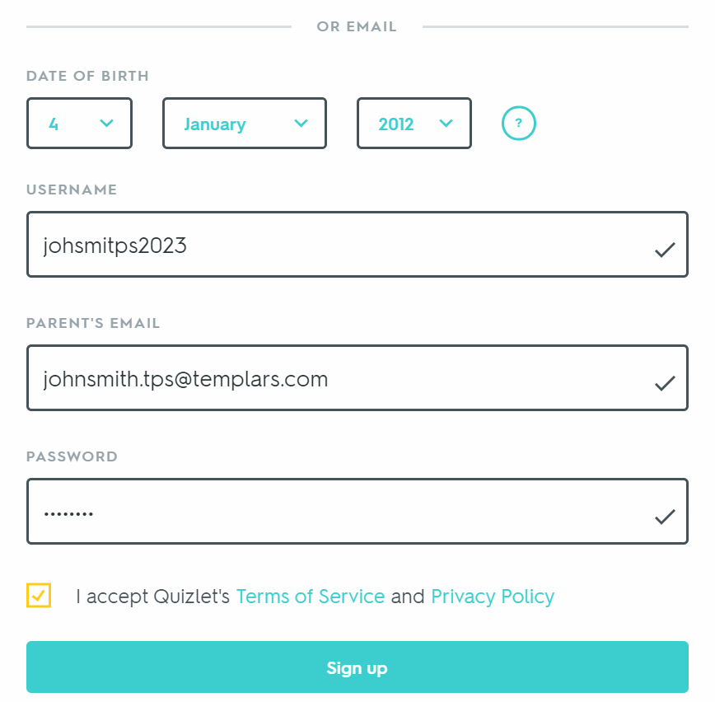

4. Once you have logged in, click here. Select your year group on the left hand side of the screen.

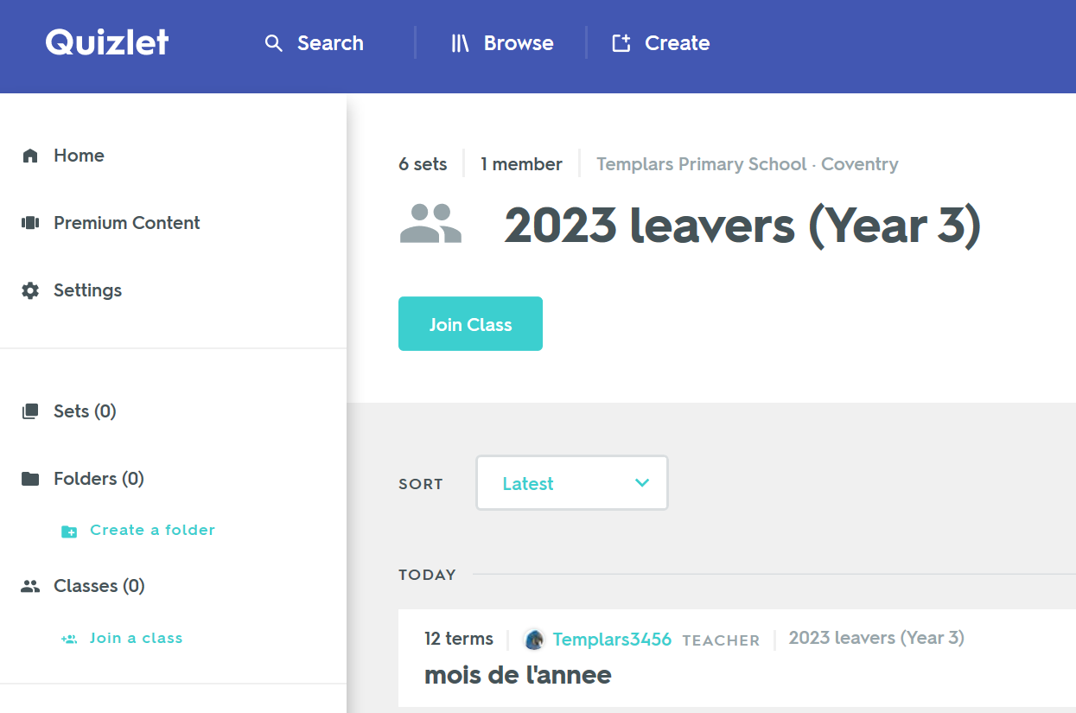

5. You will now see all the ‘sets’ that I have added to your Year group. These are all sets of language that we have learnt so far (current and past years when applicable).

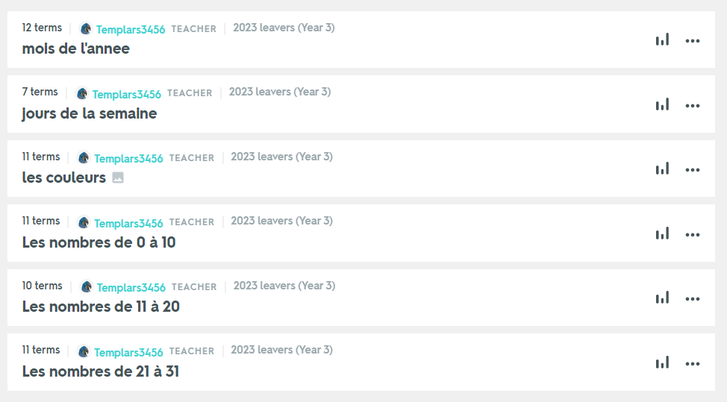

6. Choose a set to practise and you will see this:

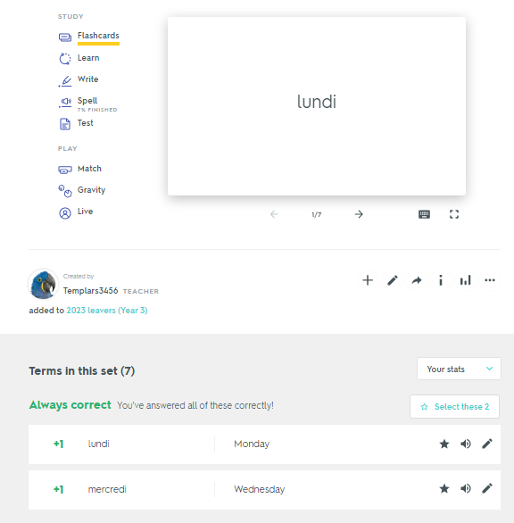

On the left-hand side are the games and activities you can do to practise these words.

At the bottom are the words that will be practised in this set. You can listen to the pronunciation here (speaker icon), and also star any words that you need to keep practising.

7. To return to the main screen, click on your year group here.

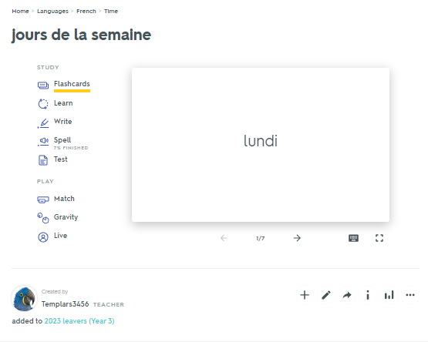

The best thing to do is to log on and explore. If you have any questions, please ask. If you have children currently in Years 4, 5 or 6, they will have used this in class, and therefore know the website quite well, and can help younger siblings. I will be able to see your scores and how often you log in to practise.