
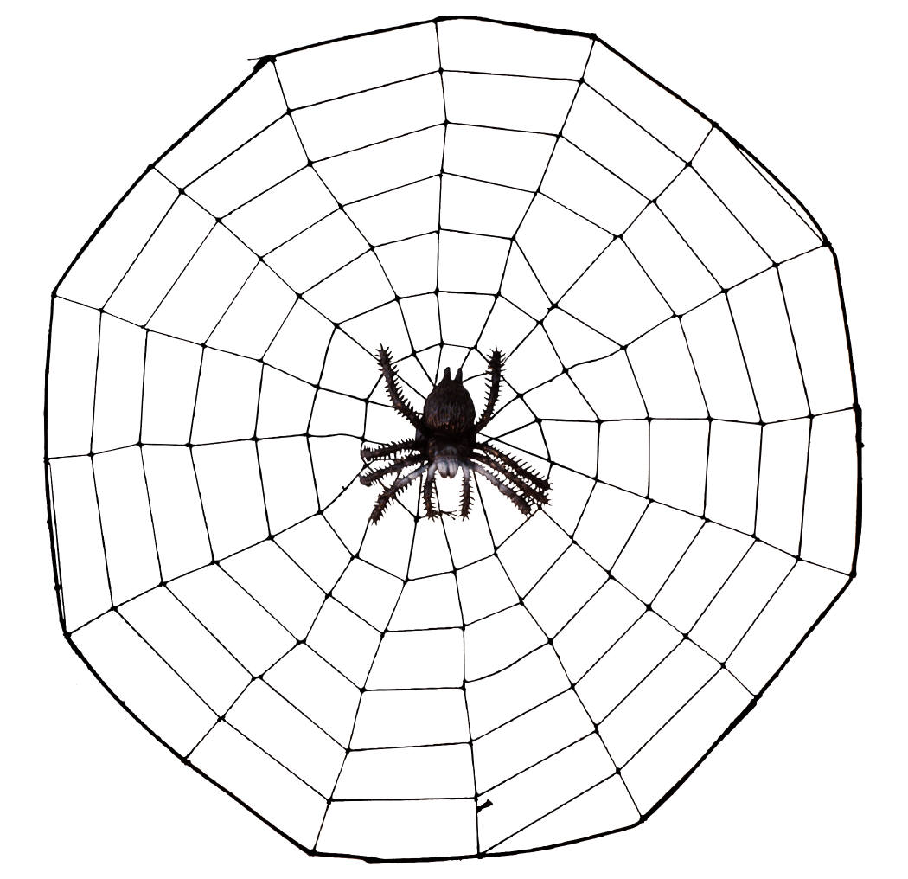
Spring 2024
Communication and Language
We will continue our adventures in Drawing Club, developing our vocabulary on a daily basis.
We will be developing our knowledge of topic-specific vocabulary, particularly based around experimenting scientifically.
Understanding of the World
Our Spring Term topic is Food Glorious Food and we will be exploring food from around the world, learning where food comes from, how it is made and what it tastes like!
The countries we have chosen to focus on this year, based on our current cohort, are Russia and India.
We will be developing our knowledge of Design and Technology through cooking and creating different meals.
Personal, Social and Emotional Development
We will be beginning our Peacemakers journey with circle times focused on our individuality, what makes us special, and what we bring to the class.
We will continue to reinforce the boundaries and expectations in Reception, which are underpinned by our Templars’ Values:
- Care
- Respect
- Honesty
Dates for your Diary
- Tuesday 16th January – Reception Vision Screening
- Monday 22nd January – Parent Event, Drawing Club
- Tuesday 6th February – Safer Internet Day
- Thursday 7th March – World Book Day
- Wednesday 19th and Thursday 20th March – Parent’s Evening
- Friday 22nd March – Teacher Training Day
Mathematics and Literacy
Continuing our theme of Food Glorious Food, we will be studying a range of books in details to develop our reading and writing abilities:
- Sam’s Sandwich
- Mr Wolf’s Pancakes
- The Tiger Who Came to Tea
- Handa’s Surprise
Physical Development
We will be continuing our adventures in Kinetic Letters:
- Gross Motor Skills such as Animal Positions, climbing, jumping, running, cycling, and scooting.
- Fine Motor Skills – wrist, hand, and finger muscles including Holding Fingers, 3 Friends, and pencil grip.
- Letter and Number Formation
We will also be learning how to keep ourselves healthy through making healthy choices regarding eating, drinking, sleeping, screen time, and road safety.
Reception Curriculum Web

